**Rise of Civilization**

**1. Civilizations rise in Mesopotamia (3500 B.C.) and Egypt (3100 B.C.).**

**a. monumental architecture**

**b. writing systems (cuneiform)**

**c. stratified society, job specialization… the soldier become a profession/job**

**d. Cities**

**e. Government centralization and administration.**

**2. Rise of civilization led to military advancements.**

**a. The walled city. The first walled city was Jericho… by 8000 B.C. Jericho had a wall, a dry moat, and a tower to protect the city gate.**

[**https://cafn.files.wordpress.com/2014/02/ancient-jericho.png**](https://cafn.files.wordpress.com/2014/02/ancient-jericho.png)

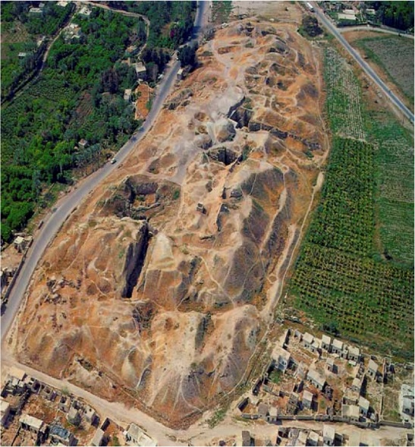

**b. Metal weapons, armor, and helmets… standardized equipment**

**c. War carts, view “Standard of Ur.” 2500 B.C. use of onagers (not horses). Chariots developed by 1700 B.C.** [**https://classconnection.s3.amazonaws.com/618/flashcards/2782618/png/standard_of_ur-140E0A34F507CC4D6FA.png**](https://classconnection.s3.amazonaws.com/618/flashcards/2782618/png/standard_of_ur-140E0A34F507CC4D6FA.png)

**d. Standing armies, full time paid armies (usually small, but supplemented by militia)**

**e. Increased reliance on the composite bow.**

**3. Summer civilization 3500 B.C. to 1800 B.C…. the first city states, and demonstrated many of the above characteristics.**

**4. Bronze Age Warfare… 3300 to 1200 BC**

**a. Bronze is an alloy made of tin and copper. Bronze was a major advancement over stone and wood. Bronze could be formed into an edged weapon that could be sharpened and formed into various forms.**

[**http://stedmundsburychronicle.com/weststowgallery/bronzeswords.jpg**](http://stedmundsburychronicle.com/weststowgallery/bronzeswords.jpg)

**5. Important military technology of the period:**

**a. Composite Bow: developed between 2000 and 1500 B.C… a bow made of several different materials. The inside curve of the bow was horn or bone. The middle was wood, and the final layer was tendon. It created force by both compression and tension (stretching). Created a bow with up to 150 lbs of drawing power, with a relatively short/small weapon. Was a product of the Steppe (central Asia).**

**b. Chariot: World’s first effective war machines (between 1700 and 1400 B.C.)… made of convergent technology (separate inventions used to make a new machine)… spoked wheel, harnesses, shooting platform all come together.**

* **Weighed about 75 lbs., man portable over rough terrain.**
* **Invented on the Steppe, probably for hunting or herding.**
* **Multiplied the speed of battle by a factor of 10**
* **Used to harass and flank the enemy.**
* **Used as a mobile archery platform.**
* **Utilized by the nobility or privileged class of a warrior society. Kings are often depicted as chariot archers. Ramses at Kadesh** [**http://www.jesuswalk.com/moses/images/ramses-ii-battle-of-kadesh-1200x835x300.jpg**](http://www.jesuswalk.com/moses/images/ramses-ii-battle-of-kadesh-1200x835x300.jpg)
* [**http://m2.i.pbase.com/u15/andrys/upload/38738762.mImg_2799.jpg**](http://m2.i.pbase.com/u15/andrys/upload/38738762.mImg_2799.jpg)
* [**http://www.photoshelter.com/img-get/I0000D07kJNJn6XQ/s/1000/665/PWP87225-149-Assyrian-Ashurnasirpal-Lion-Hunt-Nineveh.jpg**](http://www.photoshelter.com/img-get/I0000D07kJNJn6XQ/s/1000/665/PWP87225-149-Assyrian-Ashurnasirpal-Lion-Hunt-Nineveh.jpg)
* [**http://www.lessingimages.com/w2/080201/08020161.jpg**](http://www.lessingimages.com/w2/080201/08020161.jpg)

**Iron Age**

**Iron production and weapons were developed around 1400 B.C. in Anatolia (Greek word for Asia Minor… modern Turkey).**

* **1st used by the Hittites and quickly adopted by neighboring kingdoms, especially the Assyrians**
* **Clearly superior to Bronze. Lighter, stronger, and sharper.**

**Assyrians**

**The Assyrians were a fierce people rose to power in northern Mesopotamia as early as 2500 B.C. The Assyrian kingdom became an empire and lasted until its fall in 612 B.C.**

**Military advances associated with the Assyrians:**

* **1st Army to campaign more than 300 miles from base of supply, and move at speeds not improved upon until the railroad was developed. Developed an imperial road system (that’s been the model of national defense ever since)**
* **Developed specialized engineering units for river crossing, and siege warfare.**
* **Stationed forward supply depots (warehouses).**
* **Conquered all of the Fertile Crescent by 720 B.C. Incorporated conquered people into their military (Romans would follow this policy).**
* **Developed siege warfare: mines, ramps, breeches, battering rams, siege towers, terrorism.**

[**https://c1.staticflickr.com/9/8010/7524445046_18a5efaf42_z.jpg**](https://c1.staticflickr.com/9/8010/7524445046_18a5efaf42_z.jpg)

[**http://www.netours.com/images/stories/shephelah/lachish/lachish-siege-ramp-crosssec.jpg**](http://www.netours.com/images/stories/shephelah/lachish/lachish-siege-ramp-crosssec.jpg)

[**http://static.panoramio.com/photos/large/16104337.jpg**](http://static.panoramio.com/photos/large/16104337.jpg)

* **First to utilize the horse soldier from the control position. A horse had been bread with a strong enough back to be ridden.** [**http://www.photoshelter.com/img-get/I0000kpcg8hOPbcc/s/1000/665/PWP87225-114-Assyrian-Ashurnasirpal-Lion-Hunt.jpg**](http://www.photoshelter.com/img-get/I0000kpcg8hOPbcc/s/1000/665/PWP87225-114-Assyrian-Ashurnasirpal-Lion-Hunt.jpg)

Military innovations:

* Mesopotamia (Samarians, Assyrians) was a much more significant source of military innovation than Egypt. Mesopotamia had more significant threats because of its geographic location… central Asia, near Asian steppes.
* Egypt was geographically better protected by sea and desert.